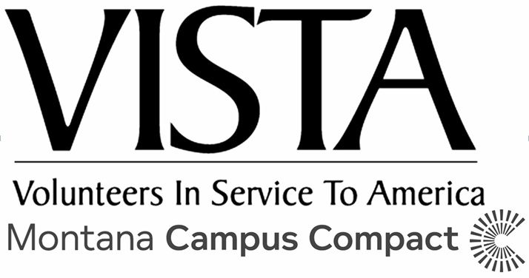

This questionnaire was created as a guidepost for new VISTAs and their supervisors to get to know one another and develop a positive and productive working relationship. If you know these things about one another from the get-go, chances are, you will be better equipped to deal with conflict, misunderstandings, and compromises that come up in the future.

INSTRUCTIONS: Both the Supervisor and the VISTA should answer each question. Share as much as you feel comfortable sharing. There is no need to record your answers, though feel free to take notes if you wish! After you have finished your conversation, sign, date, scan and email this document with the signatures to your VISTA Leader.

- What are you hoping to get out of this year? What are you most excited about? What are you nervous about?
- What pressures are on you outside of this VISTA project that will be on your mind this year or may affect you? This can be anything from other responsibilities in the supervisor’s job, family obligations, other employment, classes, life circumstances, etc.
- What are some of your strengths and weaknesses? How could these things manifest themselves this year as you work together on your VISTA project?
- What is your communication style? Do you tend to be direct or passive? How do you best absorb information?
- How do you like to receive feedback? (Verbally, face to face, written, etc.)
- What is your work style? (For example, what helps you focus? How do you prioritize your tasks and stay organized? What is your pace of work? Do you mind spontaneous conversations or would you rather schedule times to talk?)
- What is the chain of command/structure of your organization? If the supervisor is unavailable for any reason, whom should the VISTA turn to for resources, questions, etc.?
- What else would you like to share about yourself? Do you have any additional questions for one another?

Member Signature: Date:

Site Supervisor Signature: Date:

